 **“Iron Chef** **Cooking Contest”**

Enter the Uncommon Good Iron Chef Food Art Cooking Contest!

**What**: Uncommon Good is holding a food art cooking contest for its parents and students. Everyone is invited to the event. A panel of Teen Green students will judge the entries and award prizes. After the judging, there will be a tasting party where you can sample all of the dishes. You do not have to submit an entry to attend. Registration by calling (909) 625-2248 or at [ccarrillo@uncommongood.org](mailto:ccarrillo@uncommongood.org)

**When:** Friday, October 20, 6:30 pm **Where**: Uncommon Good

**Contest rules:**

1. You must pick a category to enter. The categories are:
   1. Main dish b. Side Dish c. Dessert

1. You may use Uncommon Good produce for any dish you choose. Extra points will be given to every dish containing at least one Uncommon Good produce item.

1. Bring the following completed entry form, along with your dish on the day of the contest:

---------------------------------------------------------------------------------------------------------------------

**Uncommon Good Iron Chef Cooking Contest Entry Form**

Your name: ____________________________________________________________________

Name of your dish (for example, “Kale Lasagna”):_____________________________________

The category you are entering: ____________________________________________________

The CAUSA ingredient/s you used: _______________________________________________

Bring this completed entry form, along with your dish on the day of the contest: 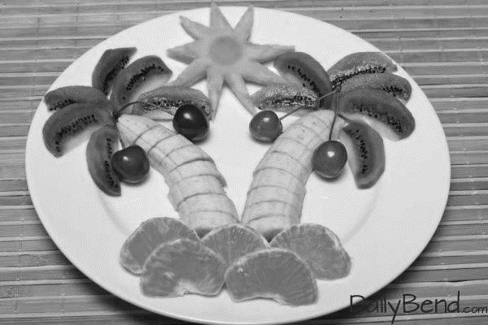

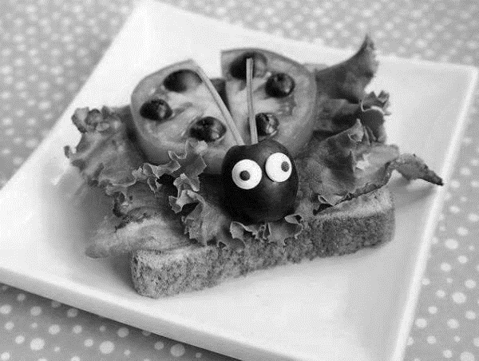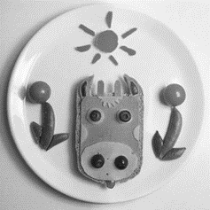

 **“Iron Chef: Concurso de Cocina”**

Cocinando con Arte en Uncommon Good!

Uncommon Good está organizando un concurso de arte culinario para los padres y estudiantes. Todos están invitados al evento. Un grupo de estudiantes adolescentes del programa Teen Green serán los jueces del evento. Después de la decisión del jurado, habrá una fiesta de degustación donde se podrá probar todos los platillos que participaron. Registración llamando al (909) 625-2248 o ccarrillo@uncommongood.org

**Fecha:** Viernes, 20 de Octubre, 2017 **Horario:** 6:30 PM **Lugar**: Uncommon Good

**Reglas del concurso:**

1. Debe elegir una categoría. Las categorías son:
2. Plato fuerte b. plato ligero c. postre

1. Pude usar cualquier vegetal de Uncommon Good si lo desea. Se le otorgaran puntos extras si su platillo contiene alguno de los vegetales de Uncommong Good.

3. Traiga esta forma completa, junto con su receta el día del concurso:

---------------------------------------------------------------------------------------------------------------------

**Uncommon Good “Iron Chef” inscripción del concurso de cocina**

Nombre: ______________________________________________________________________

Nombre de tu plato "(por ejemplo, lasaña de la col rizada (kale):

______________________________________________________________________________

Categoría: _____________________________________________________________________

El ingrediente que uso de CAUSA: _____________________________________________________________

Traiga esta forma completa, junto con su receta el día del concurso.

  