Ignacio Castuera

379 S. College Ave, Claremont, CA 91711

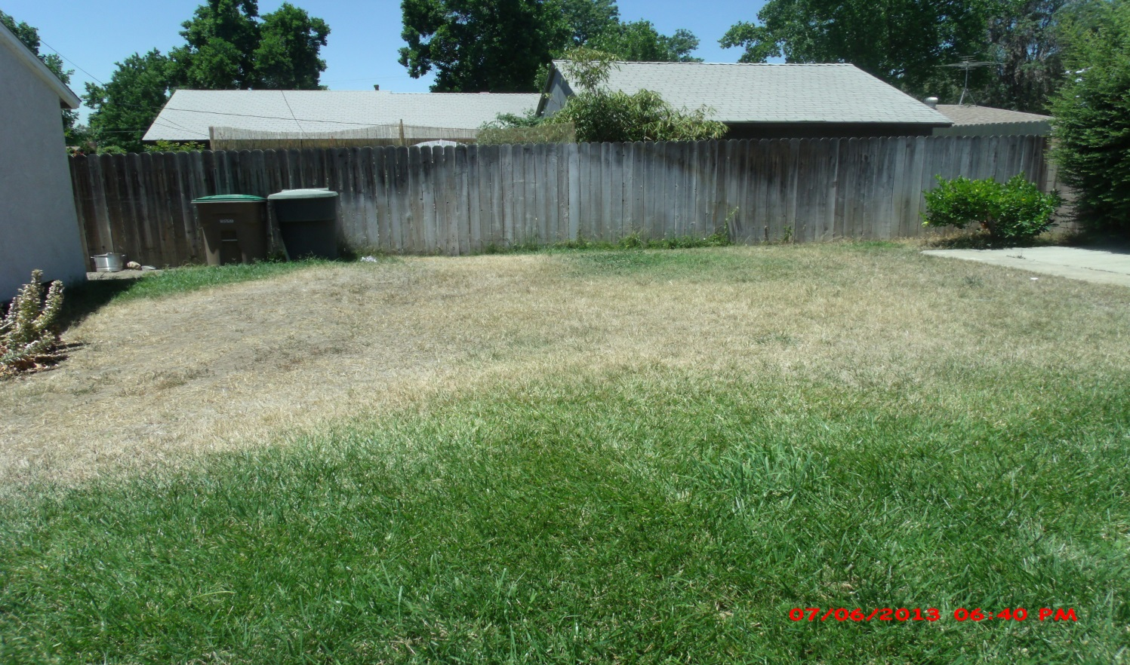Back Yard, 25 X 25 Feet

Front Yard, 26 Feet X 14 Feet

